

Project Report (Part I)

**Deep Learning Strategies For Enhanced Time Series Forecasting**

*Submitted in partial fulfillment for the award of the degree*

*Of*

**BACHELOR OF ENGINEERING**

**INFORMATION TECHNOLOGY**

Pranav Bhavsar (Roll No.:11)

Bharat Bohra (Roll No.:12)

***Under the Guidance of***

Mrs. Pranjali Kasture

**Designation**

Assistant Professor

Deputy HOD, IT Department

**Department of Information Technology**

**(Academic Year. 2024 25)**





[**TEGTEG**](http://www.thakureducation.org/)

**CERTIFICATE**

|  |  |
| --- | --- |
| Signature with Date:  Name of Guide: Pranjali Kasturi  Designation: Assistant Professor  Deputy HOD, IT Department  Date:  Place: | Signature with Date:  Name of HOD: Rajesh Bansode  Name of Department: Information Technology |

This is to certify that the project entitled **“Deep Learning Strategies For Enhanced Time Series Forecasting”** is a bonafide work of **Mr. Pranav Bhavsar (Roll No.11), Mr. Bharat Bohra(Roll No.12)** submitted to the Thakur College of Engineering and Technology, Mumbai (An Autonomous College affiliated to University of Mumbai) in partial fulfillment of the requirement for the **Project I** for award of the degree of **“Bachelor of Engineering”**in **“Information Technology ”**.



**PROJECT APPROVAL CERTIFICATE**

|  |
| --- |
| **Internal Examiner: External Examiner:** |
| Signature: Signature:  Name: Name: |
|  |

This project report entitled “**Deep Learning Strategies For Enhanced Time Series Forecasting**” by **Mr. Pranav Bhavsar (Roll No.11), Mr. Bharat Bohra (Roll No.12)** is approved for the degree of **“Bachelor of Engineering”** in **“Information Technology”**.

**Acknowledgement**

It would be unfair if I do not acknowledge the help and support given by Professors, students, friends etc.

We sincerely thank our guide Ms. Pranjali Kasturi for his/her guidance and constant support and also for the stick to our backs. We also thank the project coordinators for arranging the necessary facilities to carry out the project work.

We thank the HOD, Dr. Rajesh Bansode, the Principal, Dr. B. K. Mishra and the college management for their support.

Pranav Bhavsar (Roll No.:11)

Bharat Bohra (Roll No.:12)

Plagiarisms Report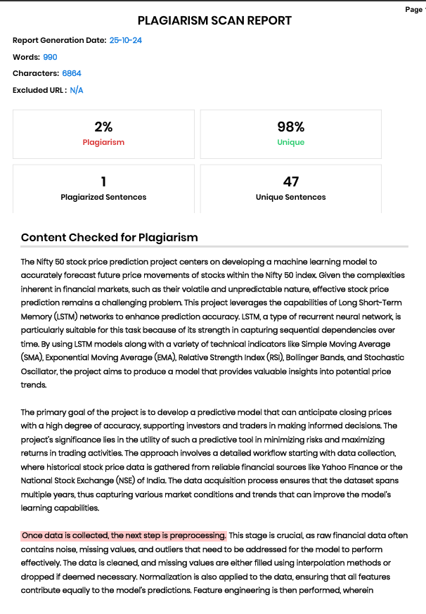

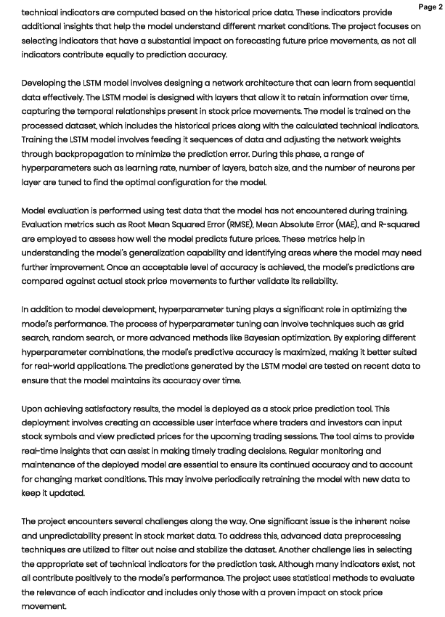 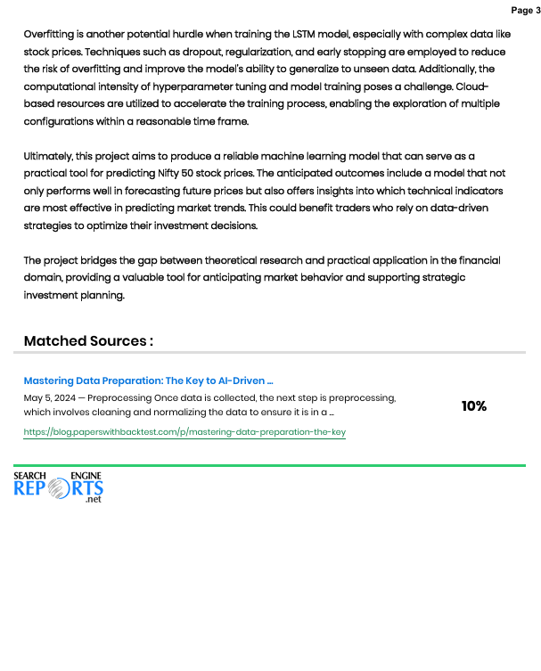

**INDEX**

|  |  |  |  |
| --- | --- | --- | --- |
| **Chapter No.** | **Topic** | | **Page No.** |
|  | * List of Figures | | **I** |
|  | * List of Tables | | **II** |
|  | **Abstract** | | **III** |
| **Chapter 1** | **Introduction** | | **IX** |
|  | 1.1 | Introduction | **IX** |
|  | 1.2 | Motivation | **IX** |
|  | 1.3 | Problem Definition | **X** |
|  | 1.4 | Objectives of project | **X** |
|  | 1.5 | Scope of the Project | **X** |
|  | 1.6 | Application of the project | **X** |
|  | 1.7 | Expected outcome of the project | **XI** |
|  | 1.8 | Organization of the Project Report | **XI** |
| **Chapter 2** | **Proposed System** | | **XIII** |
|  | 2.1 | Survey of Literature/Existing System | **XIII** |
|  | 2.2 | Limitations of Existing System/Gap Analysis | **XIV** |
|  | 2.3 | Proposed System | **XV** |
| **Chapter 3** | **Requirement Gathering, Analysis and Planning** | | **XIX** |
|  | 3.1 | Requirement Specification | **XIX** |
|  | 3.2 | Feasibility Study | **XX** |
|  | 3.3 | Methodology | **XXI** |
|  | 3.4 | Technology | **XXII** |
|  | 3.5 | Gantt Chart and Process Model | **XXIII** |
|  | 3.6 | System Analysis (functional model, structural model and behavioral model) | **XXIV** |
| **Chapter 4** | **System Design and Experimental Set up** | | **XXV** |
|  | 4.1  4.2 | Data Flow Diagram/ Physical layout/ Block diagram  Algorithm/Flowchart/Pseudo Code Design/ UML Diagrams | **XXV** |
|  | 4.3 | User Interface Design (Snapshots) (If applicable) | **XXVI** |
|  | 4.4 | Details about input to systems or selected data | **XXVII** |
|  | 4.5 | Performance Evaluation Parameters (for Validation) | **XXVII** |
|  | 4.6 | Software and Hardware Set up | **XXVII** |
| **Chapter 5** | **Conclusion** |  | **XXIX** |
|  | **5.1** | Summary of work completed | **XXIX** |
|  | **5.2** | Implementation Plan for Next Semester | **XXXI** |

**References**

**Proposed Research Paper**

**Appendix A**

* Abbreviation and symbols

**Appendix B**

* Definitions

**Appendix C**

* List of Publications

**List of Figures**

|  |  |
| --- | --- |
| **FIGURES** | **PAGE NO** |
| 3.5.1: Gnatt Chart | **XXIII** |
| 4.1.1: Model Architecture | **XXV** |
| 4.1.2: Block Diagram | **XXVI** |
| 4.1.3: LSTM Model | **XXVI** |
| 5.1.1: RSI Diagram | **XXIX** |
| 5.1.2: EMA Diagram | **XXX** |
| 5.1.3: LSTM trained model | **XXXI** |

**List of Tables**

2.1:

|  |  |  |
| --- | --- | --- |
| Table No. | Table Details | Page No |
| NIL | NIL | NIL |

**Chapter 1**

**Introduction**

### Introduction

### Stock market prediction has always been a topic of significant interest in the field of finance. Given the inherent volatility and complexity, predicting stock prices accurately can greatly benefit investors and traders. In this project, we employ a machine learning approach, specifically Long Short Term Memory (LSTM) networks, to forecast future stock prices based on historical data from the Nifty 50 index. By utilizing technical indicators such as Relative Strength Index (RSI), Moving Average Convergence Divergence (MACD), and Exponential Moving Averages (EMA), we aim to enhance the predictive accuracy of the model. These indicators are widely used in technical analysis to identify trends and potential reversal points, making them valuable features for a predictive model.

### 1.2. Motivation

### The stock market is a crucial component of the global economy, and accurate forecasting of stock prices can provide significant financial advantages. However, predicting the market is challenging due to its dynamic nature and numerous influencing factors. Traditional statistical methods have limitations when dealing with non linear patterns in time series data. Therefore, machine learning algorithms, especially deep learning models like LSTM, which excel in handling sequential data, present a promising solution. This project is motivated by the need for an efficient predictive model that can support decision making in trading and investment by leveraging technical indicators to improve forecasting performance.

### 1.3. Problem Definition

### The primary problem addressed in this project is the prediction of future stock prices for the Nifty 50 index using historical data. The goal is to build a machine learning model that can analyze past trends and predict the next day's price, helping investors make informed trading decisions. The challenge is to effectively use multiple technical indicators and time series data to train the model while avoiding overfitting and ensuring robust generalization on unseen data.

### 1.4. Objectives of the Project

### Data Collection and Preprocessing: Collect daily OHLC (Open, High, Low, Close) data of the Nifty 50 index and apply necessary preprocessing techniques such as scaling the data using MinMaxScaler.

### Feature Engineering: Calculate technical indicators like RSI, MACD, EMA, and SMA for different periods (20, 50, 100, 150, and 200 days).

### Model Development: Implement LSTM networks to capture the sequential dependencies and patterns in the data.

### Evaluation: Assess the model's performance using relevant metrics and visualize the predictions compared to actual stock prices.

### Optimization: Tune hyperparameters to improve model accuracy and avoid overfitting.

### 1.5. Scope of the Project

### The project focuses on predicting the future stock price movements of the Nifty 50 index using historical data and technical indicators. The scope includes:

### Analyzing daily data to predict the next day's closing price.

### Utilizing deep learning techniques like LSTM to exploit the temporal dependencies in stock price movements.

### Incorporating multiple technical indicators to enhance the model's predictive capability.

### 1.6. Application of the Project

### Stock Market Trading: The predictive model can be used by traders to identify potential entry and exit points based on the expected price movement.

### Algorithmic Trading Systems: It can be integrated into automated trading algorithms that execute trades based on the predictions.

### Financial Advisory Services: Financial analysts can use this model to support their recommendations for clients.

### Risk Management: Investors can use the predictions to better manage risks by understanding potential price movements.

### 1.7. Expected Outcome of the Project

### A trained LSTM model capable of predicting the next day's stock price for the Nifty 50 index.

### Improved prediction accuracy when using a combination of technical indicators compared to using raw price data alone.

### Visualization of predicted vs. actual stock prices over time, demonstrating the model's effectiveness in capturing market trends.

### 1.8. Organization of the Project Report

### The report will be structured as follows:

### Chapter 1: Introduction

### Overview of stock market prediction and the significance of using machine learning models.

### Chapter 2: Literature Review

### Examination of previous studies and approaches to stock market forecasting using machine learning and deep learning techniques.

### Chapter 3: Methodology

### Detailed description of data collection, preprocessing, technical indicators used, and LSTM model development.

### Chapter 4: Implementation

### Step by step explanation of how the model was implemented, including code snippets and software used.

### Chapter 5: Results and Analysis

### Presentation of model performance, evaluation metrics, and visualizations comparing predictions with actual stock prices.

### Chapter 6: Discussion

### Analysis of the results, potential limitations of the model, and areas for improvement.

### Chapter 7: Conclusion and Future Work

### Summary of findings, practical implications, and suggestions for extending the project.

**Chapter 2**

**Proposed System**

### 2.1. Survey of Literature/Existing System

### The prediction of stock prices has been a well researched area, with various approaches ranging from statistical methods to advanced machine learning algorithms. A few common methods used in previous studies include:

### Traditional Statistical Methods

### Autoregressive Integrated Moving Average (ARIMA) : A popular statistical approach used for time series forecasting, ARIMA models rely on linear dependencies within the data. However, they struggle with non linear patterns, making them less suitable for stock market prediction, which often exhibits complex, non linear behaviors.

### Exponential Smoothing Models (e.g., Holt Winters) : These models are also used for time series forecasting, applying exponential weighting to past observations. Although they perform well for short term predictions, they are limited in capturing long term trends and non linear dependencies.

### Machine Learning Approaches

### Support Vector Machines (SVMs) : These algorithms can capture non linear relationships in the data by using kernel functions. SVMs have shown some success in stock market forecasting, but they require significant feature engineering and cannot inherently model sequential data.

### Random Forests and Gradient Boosting Machines (GBMs) Ensemble learning methods like Random Forests and GBMs can handle non linear relationships and interactions in the data. However, they do not naturally account for temporal dependencies in time series data.

### Deep Learning Approaches

### Artificial Neural Networks (ANNs): Early deep learning models such as ANNs have been applied to stock prediction but often suffer from issues in capturing long term dependencies in sequential data.

### Long Short Term Memory (LSTM) : LSTM networks are a type of Recurrent Neural Network (RNN) specifically designed to handle sequential data by retaining information over long periods. LSTMs have shown substantial improvements in time series forecasting tasks, including stock price prediction, due to their ability to model long term dependencies and trends.

### Use of Technical Indicators in Stock Prediction

### Technical indicators like RSI, MACD, EMA, and SMA are widely used by traders for market analysis. Studies have shown that combining these indicators with machine learning models can improve prediction accuracy by providing insights into market momentum, trends, and potential reversal points.

### Many existing models utilize these indicators in conjunction with LSTM or other neural networks to predict stock prices. However, the effectiveness of different combinations of indicators and model architectures can vary significantly.

### 2.2 Limitations of Existing System/Gap Analysis

### Despite the advancements in stock price prediction, existing systems have some limitations:

### Inability to Capture Complex Non Linear Patterns Fully

### Traditional methods like ARIMA are limited to linear relationships, making them less effective for the inherently non linear nature of stock price movements.

### Although machine learning models like SVMs can capture some non linear relationships, they do not account for the sequential aspect of the data.

### Challenges in Incorporating Technical Indicators

### Existing systems may not optimally combine various technical indicators, resulting in suboptimal feature selection and reduced predictive performance.

### Some models rely solely on historical price data without using technical indicators, potentially missing valuable information that could enhance prediction accuracy.

### Limited Use of Deep Learning in Time Series Forecasting

### While deep learning approaches such as LSTM have shown promise, many existing models fail to leverage the full potential of LSTM networks, such as using multiple layers or bidirectional LSTMs.

### There is also a lack of standardization in selecting hyperparameters, training techniques, and data preprocessing methods, leading to inconsistencies in model performance.

### Overfitting and Lack of Robustness in Predictions

### Many predictive models struggle with overfitting, especially when training on small datasets or using complex model architectures.

### The absence of robust validation techniques can lead to models that perform well on training data but fail to generalize to unseen data.

### 2.3. Proposed System

### The proposed system aims to address the limitations mentioned above by developing a robust stock price prediction model using LSTM networks combined with technical indicators for the Nifty 50 index. The key components of the proposed system are as follows:

### Data Collection and Preprocessing

### The system will collect daily OHLC (Open, High, Low, Close) data for the Nifty 50 index.

### A MinMax scaler will be applied to normalize the data, ensuring all features are on a similar scale, which helps in speeding up the convergence of the LSTM model during training.

### Technical indicators such as RSI, MACD, EMA, and SMA for different time periods (20, 50, 100, 150, and 200 days) will be calculated and added as additional features to the dataset.

### Feature Engineering

### The inclusion of multiple technical indicators aims to capture different aspects of market behavior. For instance, EMA and SMA will help in understanding the trend direction, while RSI and MACD will provide insights into momentum and potential reversal points.

### The use of technical indicators as features is expected to enhance the model's ability to understand and predict stock price movements.

### Model Development with LSTM Networks

### The proposed system will use LSTM networks due to their capability to capture temporal dependencies in time series data. LSTM’s architecture, with its memory cell and gating mechanisms, is well suited for learning from sequential data like stock prices.

### To improve model accuracy, various architectures will be explored, such as single layer LSTM, multi layer LSTM, and possibly bidirectional LSTM to better understand trends from both past and future data points.

### Hyperparameter Tuning and Optimization

### Hyperparameters such as the number of LSTM layers, number of neurons per layer, learning rate, batch size, and number of epochs will be tuned to achieve optimal performance.

### Regularization techniques such as dropout will be employed to prevent overfitting.

### Model Evaluation and Validation

### The model's performance will be evaluated using metrics such as Mean Absolute Error (MAE), Root Mean Squared Error (RMSE), and R squared.

### A thorough validation process using techniques like cross validation and time based splitting will ensure the robustness of the model.

### Visualization and Result Analysis

### Predicted vs. actual stock prices will be visualized to assess the model's effectiveness in capturing market trends.

### Important features contributing to the model's predictions will be analyzed, providing insights into the most influential technical indicators.

### Advantages of the Proposed System

### Enhanced Predictive Accuracy: By combining multiple technical indicators with an LSTM based approach, the proposed system is expected to outperform traditional statistical models and basic machine learning approaches.

### Handling Non Linearity and Temporal Dependencies: LSTM networks' ability to learn from sequential data will allow the model to better understand complex patterns in stock price movements.

### Scalability and Adaptability: The system can be extended to other stock indices or financial instruments by modifying the data preprocessing and feature engineering steps.

**Chapter 3**

**Requirement Gathering, Analysis and Planning**

### 3.1. Requirement Specification

### The project aims to create a predictive model for forecasting Nifty 50 stock prices using a Long Short Term Memory (LSTM) network, with the help of technical indicators such as RSI, MACD, EMA, and SMA. The requirements for this project can be divided into functional and non functional requirements.

### A. Functional Requirements

### Data Collection: The system should collect daily OHLC (Open, High, Low, Close) data for the Nifty 50 index.

### Data Preprocessing: Normalize the dataset using a MinMax scaler and compute the technical indicators (RSI, MACD, EMA, and SMA for 20, 50, 100, 150, and 200 days).

### Model Training: Train the LSTM network on the processed data, incorporating technical indicators as features.

### Prediction and Visualization: Provide accurate stock price forecasts and plot actual vs. predicted values for analysis.

### Performance Evaluation: Evaluate the model using metrics like Mean Absolute Error (MAE), Root Mean Squared Error (RMSE), and R squared.

### B. Non Functional Requirements

### Scalability: The system should be adaptable to predict other stock indices by adjusting the data processing and model parameters.

### Efficiency: The model training process should be optimized to reduce training time while maintaining accuracy.

### Robustness: Implement measures to avoid overfitting and ensure the model generalizes well to unseen data.

### Usability: The results and visualizations should be clear and interpretable for decision making.

### 3.2. Feasibility Study

### The feasibility study helps in assessing the viability of the project across different dimensions: technical, operational, and economic feasibility.

### Technical Feasibility

### The project requires tools for data processing, model building, and visualization. Python based libraries like Pandas, NumPy, Scikit learn, TensorFlow/Keras, and Matplotlib can be used effectively.

### The availability of daily stock data for the Nifty 50 index ensures that data requirements are met.

### LSTM networks are suitable for time series forecasting tasks, making the project technically feasible.

### Operational Feasibility

### The project will be implemented as a predictive model that can be easily integrated into existing decision making processes for traders.

### Technical knowledge in data processing and machine learning, which is necessary for implementation, is readily available.

### Economic Feasibility

### Open source tools and libraries will be used, minimizing costs.

### The potential benefits, such as improved stock trading strategies and decision making, outweigh the development costs.

### 3.3. Methodology

### The methodology for the project involves several phases: data collection, data preprocessing, feature engineering, model training, evaluation, and deployment.

### Data Collection

### Collect daily OHLC data for the Nifty 50 index from a reliable data source such as Yahoo Finance or an Indian stock market data provider.

### The data should span a significant time frame (e.g., 5–10 years) to capture different market conditions.

### Data Preprocessing

### Normalize the OHLC data using a MinMax scaler to transform the values between 0 and 1, helping the LSTM model converge faster.

### Handle any missing data points by using forward fill or linear interpolation.

### Feature Engineering

### Calculate technical indicators such as Relative Strength Index (RSI), Moving Average Convergence Divergence (MACD), Exponential Moving Average (EMA), and Simple Moving Average (SMA) for various time periods (20, 50, 100, 150, 200 days).

### Use these indicators as additional features in the model to improve predictive accuracy.

### Model Development (LSTM)

### Build an LSTM network with layers that can capture the sequential nature of the time series data.

### Configure the network with appropriate hyperparameters, such as the number of layers, number of neurons, learning rate, and dropout for regularization.

### Split the dataset into training and testing sets to evaluate the model's generalization capability.

### Model Evaluation

### Use evaluation metrics such as MAE, RMSE, and R squared to assess the model's performance.

### Perform cross validation and hyperparameter tuning to optimize model performance.

### Deployment and Visualization

### Deploy the model for real time prediction or backtesting.

### Visualize the predicted vs. actual stock prices to analyze the model's accuracy.

### 

### 3.4. Technology

### Programming Language

### Python: Widely used for machine learning and data science projects.

### Libraries and Tools

### Data Processing: Pandas and NumPy for data manipulation and preprocessing.

### Machine Learning: TensorFlow/Keras for building and training the LSTM model.

### Data Visualization: Matplotlib and Seaborn for plotting graphs and visualizing predictions.

### Scikit learn: For data scaling and evaluation metrics.

### Development Environment

### Jupyter Notebook or Visual Studio Code for code development and execution.

### 3.5. Gantt Chart and Process Model

### A. Gantt Chart

### Output image

### *3.5.1 Gantt Chart*

### B. Process Model

### A linear sequential (waterfall) model can be used for the project, as it follows a step by step approach:

### Requirement Analysis : Define project requirements.

### System Design : Design data preprocessing, feature engineering, and model architecture.

### Implementation : Code the LSTM model and perform data processing.

### Testing : Evaluate the model's performance.

### Deployment : Deploy the model and visualize results.

### Maintenance : Update the model periodically as new data becomes available.

### 3.6. System Analysis

### Functional Model

### The system's main function is to predict future stock prices based on past OHLC data and technical indicators.

### Input: Daily OHLC data for Nifty 50 and computed indicators.

### Processing: The LSTM model processes this data to forecast future prices.

### Output: Predicted stock price for the next day or specified future period.

### Structural Model

### Data Flow Diagram (DFD): Illustrates the flow of data from input (OHLC data) through data preprocessing, feature extraction, model training, and prediction.

### Entity Relationship Diagram (ERD): Represents relationships between datasets (OHLC data, technical indicators) and the LSTM model.

### Behavioral Model

### State Transition Diagram: Shows the state changes from data preprocessing to feature engineering, model training, evaluation, and deployment.

### Sequence Diagram: Details the sequence of operations performed by the system, from data collection to prediction output.

### These components offer a comprehensive analysis of the system, ensuring the project is well structured and thoroughly planned, setting a solid foundation for successful implementation.

### Chapter 4

### System Design And Experimental Setup

### 4.1. Block Diagram

### 

### *Fig 4.1.1 Model Architecture*

### *Fig 4.1.2 Block diagram*

### Output image

### *Fig 4.1.3 LSTM Model*

### 4.2. Pseudo Code

### Step 1: Collect daily OHLC data for Nifty 50.

### Step 2: Preprocess the data (MinMax scaling, handle missing values).

### Step 3: Compute technical indicators (RSI, MACD, EMA, SMA).

### Step 4: Split the data into training and testing sets.

### Step 5: Train the LSTM model on the training data.

### Step 6: Predict stock prices using the trained model on test data.

### Step 7: Evaluate model performance using error metrics by hypertune if needed .

### Step 8: Plot the predicted vs. actual stock prices.

### 4.4. Details About Input to Systems or Selected Data

### Input Data

### OHLC Data : Daily Open, High, Low, Close prices for Nifty 50 over several years.

### Technical Indicators : Computed from the OHLC data, including RSI, MACD, EMA, and SMA.

### Data Preprocessing Requirements

### Normalization : Apply MinMax scaling to scale values between 0 and 1.

### Indicator Calculation : Use formulas for calculating RSI, MACD, EMA, and SMA.

### 4.5. Performance Evaluation Parameters (for Validation)

### Evaluation metrics help to measure the accuracy and effectiveness of the model:

### Mean Absolute Error (MAE): Measures the average magnitude of errors in predictions.

### Root Mean Squared Error (RMSE): Evaluates the square root of the average squared differences between actual and predicted values.

### R squared: Indicates how well the predictions match the actual values.

### Training and Validation Loss: Plots to monitor the model's learning curve and detect overfitting.

### 4.6. Software and Hardware Setup

### Software Setup

### Python 3.x : The primary programming language.

### Libraries : Pandas, NumPy, TensorFlow/Keras, Scikit learn, Matplotlib, Seaborn.

### Development Environment : Jupyter Notebook or Visual Studio Code.

### Hardware Setup

### CPU/GPU : A system with a high performance CPU or a GPU (NVIDIA CUDA capable GPU for faster training).

### RAM : Minimum 8 GB, recommended 16 GB or more for better performance.

### Storage : Sufficient space to store data and intermediate results (at least 100 GB).

### Chapter 5

### Conclusion

### 5.1. Summary of Work Completed

### The project aimed at predicting Nifty 50 stock prices using machine learning techniques has made significant progress. Here is an overview of the work completed:

### Data Collection and Preprocessing

### Daily OHLC (Open, High, Low, Close) data for Nifty 50 was collected.

### Data preprocessing involved handling missing values, applying MinMax scaling for normalization, and preparing the data for further analysis.

### Feature Engineering

### Several technical indicators were computed to enhance the dataset's predictive power. These included:

### C:\Users\prana\AppData\Local\Microsoft\Windows\INetCache\Content.MSO\A319B458.tmpRelative Strength Index (RSI)

### Moving Average Convergence Divergence (MACD)

### C:\Users\prana\AppData\Local\Microsoft\Windows\INetCache\Content.MSO\AF7D5B24.tmpExponential Moving Averages (EMA) for 20, 50, 100, 150, and 200 days

### Simple Moving Averages (SMA) for 20, 50, 100, 150, and 200 days

### Model Development

### C:\Users\prana\AppData\Local\Microsoft\Windows\INetCache\Content.MSO\44211426.tmpAn LSTM (Long Short Term \Memory) model was built to predict the future prices

### based on the processed data and technical indicators.

### The model architecture was designed with layers optimized for time series forecasting, with attention to hyperparameter tuning.

### Training and Evaluation

### The LSTM model was trained on historical data, and its performance was assessed using metrics such as MAE (Mean Absolute Error), RMSE (Root Mean Squared Error), and R squared to validate the prediction accuracy.

### C:\Users\prana\AppData\Local\Microsoft\Windows\INetCache\Content.MSO\A2A2D03A.tmpVisualization techniques were employed to plot the actual vs. predicted values for better understanding.

### *5.1.3:.LSTM TRAINED MODEL*

### Results Analysis

### The initial results were analyzed to understand the LSTM model's predictive capabilities and areas for improvement.

### The outcomes revealed certain limitations in terms of prediction accuracy, suggesting potential for further refinement and experimentation with other models.

### 5.2. Implementation Plan for Next Semester

### To improve the predictive accuracy and explore alternative approaches, the following implementation plan is proposed for the next semester:

### Implementing GRU (Gated Recurrent Unit)

### Objective : GRU, being a variant of LSTM, can potentially offer better performance for time series data with fewer parameters, thus reducing training time and overfitting.

### Plan : Implement a GRU based model for predicting Nifty 50 prices, replacing or complementing the LSTM model.

### Perform hyperparameter tuning to optimize the number of layers, units, activation functions, and regularization techniques.

### Compare the GRU model's performance against the LSTM in terms of prediction accuracy, training time, and computational efficiency.

### Implementing Facebook Prophet

### Objective: The Prophet model, developed by Facebook, is specifically designed for time series forecasting, including trends, seasonality, and holiday effects. It can be used to model stock price patterns.

### Plan: A forecasting model using the Prophet library to predict future prices based on historical data.

### Fine tune the parameters to handle stock market specific seasonality, such as daily, weekly, and monthly cycles.

### Combine the predictions of Prophet with the LSTM/GRU models to see if an ensemble approach can improve the overall accuracy.

### Improving Accuracy with Hybrid Models

### Objective: To enhance model performance by combining the strengths of different algorithms.

### Plan: Develop a hybrid approach that combines LSTM/GRU with Prophet to leverage both deep learning and traditional statistical modeling.

### Experiment with various ensembling techniques such as stacking or weighted averaging to blend the predictions from the different models.

### Validate the accuracy improvement using performance metrics (MAE, RMSE, R squared) across different approaches.

### Parameter Tuning and Model Optimization

### Objective: To achieve higher accuracy by refining model parameters and data preparation techniques.

### Plan: Optimize hyperparameters for the existing LSTM model and the newly implemented GRU and Prophet models.

### Test different scaling techniques (e.g., StandardScaler, RobustScaler) to see if they improve model performance.

### Evaluate different sequence lengths and input features to optimize the data fed into the models.

### Data Augmentation and Feature Engineering

### Objective: Enhance the dataset to improve predictive power.

### Plan: Introduce additional technical indicators or macroeconomic factors that could influence Nifty 50 prices.

### Implement techniques such as rolling windows and lagged features to augment the dataset.

### Integration and Continuous Deployment

### Objective: Make the system more flexible and adaptable for real time usage.

### Plan: Set up a pipeline for continuous integration and deployment to automate data collection, model training, and prediction updates.

### Deploy the model on a cloud platform (e.g., AWS, Google Cloud) to facilitate real time predictions and live testing.

### Validation and Performance Evaluation

### Objective: Ensure robustness and generalizability of the models.

### Plan: Perform cross validation with different time splits to verify the stability of the models.

### Evaluate the predictions using advanced performance metrics such as directional accuracy and trading signal efficiency.

### By implementing GRU, Prophet, and a hybrid approach, and fine tuning the models, the project aims to significantly enhance the accuracy and reliability of Nifty 50 stock price predictions in the next semester.

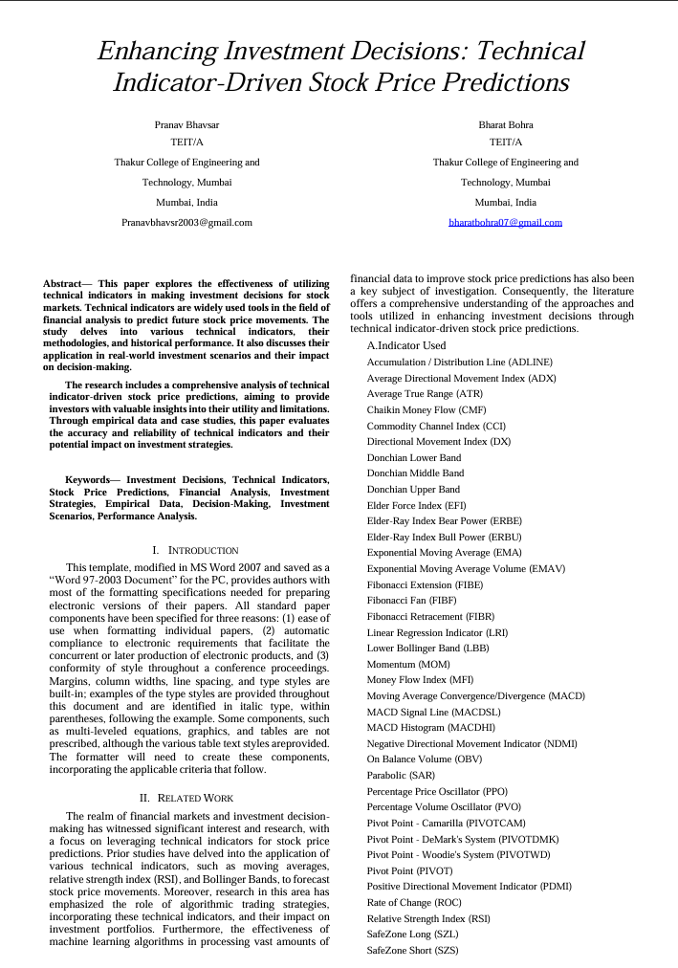**Appendix C**

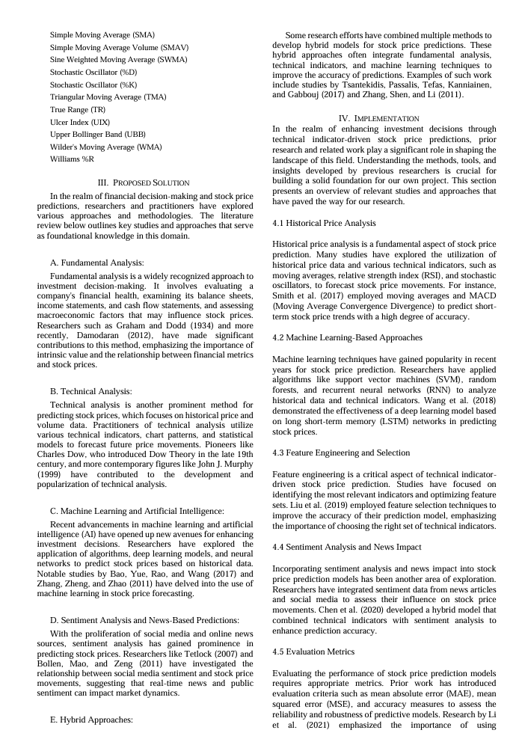

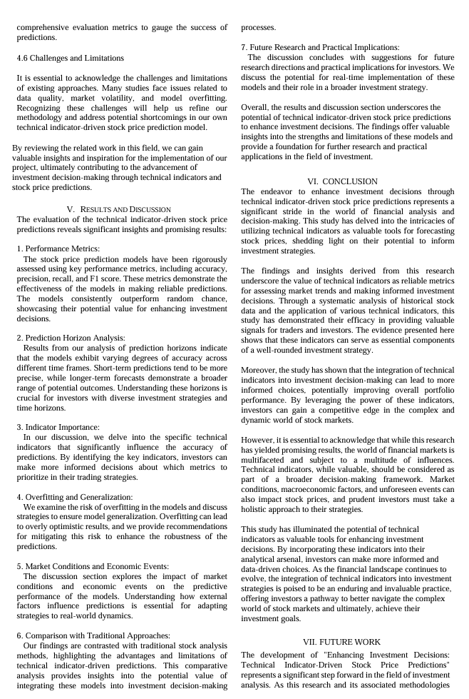

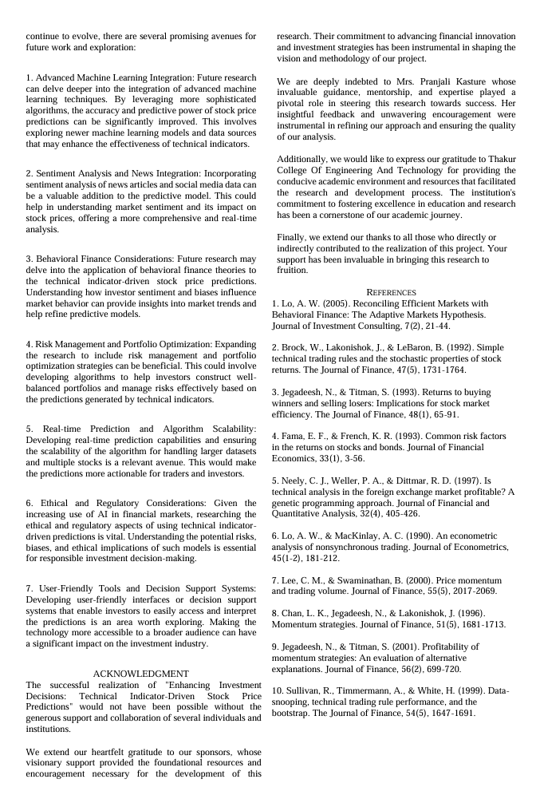

**REFERENCE**

* [**https://ieeexplore.ieee.org/document/8703332**](https://ieeexplore.ieee.org/document/8703332)
* [**https://ieeexplore.ieee.org/document/6740438**](https://ieeexplore.ieee.org/document/6740438)
* [**https://www.sciencedirect.com/science/article/pii/S1877050918307828**](https://www.sciencedirect.com/science/article/pii/S1877050918307828)
* [**https://journalofbigdata.springeropen.com/articles/10.1186/s40537-020-00333-6**](https://journalofbigdata.springeropen.com/articles/10.1186/s40537-020-00333-6)
* [**https://www.researchgate.net/publication/354268488_Stock_market_prediction_using_deep_learning_algorithms**](https://www.researchgate.net/publication/354268488_Stock_market_prediction_using_deep_learning_algorithms)